RepRapPro Mendel V1.1

## Introduction

These pages are the complete instructions for building, commissioning and using the [RepRapPro Ltd](http://reprappro.com/) version of RepRap Mendel.

Like all RepRap machines, [RepRapPro Mendel](http://reprappro.com/Mendel) is fully open-source. It is licenced under the GPL. All the design files and software are available from the [RepRapPro Ltd Github](https://github.com/reprappro) repository. And it is [here in the Thingiverse](http://www.thingiverse.com/thing:20968).

If you want to print the plastic parts for a RepRapPro Mendel, [see this wiki page](http://reprap.org/wiki/How_to_Print_RepRapPro_Mendel).

RepRapPro Mendel 1.1 is based on the previous RepRap Pro Mendel with many alterations and additions. It was designed in order to further simplify assembly and to increase build volume when using multiple extruder.

These instructions document the assembly of a single material/colour “Mono” Mendel. It is recommended that even multicolour machines are initially assembled as Mono mendels, before being extended to a multicolour machine after a testing.

General notes

Give yourself plenty of space and ensure your work area is clean. Dust and dirt are a 3D printer's worst enemy. All printed parts have been printed on various RepRap machines from suppliers within the RepRap community. Despite the fact that these machines are highly tuned RepRap 3D printers, some holes and features may need a little fettling to get the best performance from your machinel. This is especially true for the Igus bushings used for the Z axis. There is a video how-to on fettling 3D printed parts [here on Vimeo](http://vimeo.com/14492980).

Before you start the build, please ensure you have all the components as listed on the packing list included in the kit. If anything is missing, please contact us via email: A description...

We understand that people may want to change aspects of the machine's design, and in fact we encourage this as it is one of the benefits of open source development. Before changing anything, please be aware that the RepRapPro Mendel has been designed to maximise the build volume relative to the the machine's footprint, and as such many of its components fit closely to others. So consider your changes carefully before you try to implement them. And when you find improvements, please tell us so that we can include them in future kits, and so that existing owners can upgrade their own machines.

BEFORE YOU ATTEMPT TO ASSEMBLE ANY PART OF THE RepRapPro Mendel 3D PRINTER, PLEASE READ THESE BUILD INSTRUCTIONS FULLY AND ENSURE YOU UNDERSTAND THEM. Although all parts are covered by warranty, this will be invalidated by your not following these build instructions. If anything is unclear please get in contact with support prior to assembly in order to ensure no damage caused to your machine.

The RepRapPro Mendel is a robust RepRap machine once assembled; however it does require a certain amount of care during assembly. If in doubt, force is usually not the answer! There are many ways to get support and advice, see the Get Support section below.

If you can't see clearly from the pictures what's going on click on the picture and open it in a new browser tab. This will take you to a page in this wiki where you can see a high-resolution version of the picture.

Table of Contents

1. [Frame assembly](http://reprap.org/wiki/RepRapPro_Mendel_frame_assembly)
2. [Y axis assembly](http://reprap.org/wiki/RepRapPro_Mendel_y_axis_assembly)
3. [X axis assembly](http://reprap.org/wiki/RepRapPro_Mendel_x_axis_assembly)
4. [Z axis assembly](http://reprap.org/wiki/RepRapPro_Mendel_z_axis_assembly)
5. [Heated bed assembly](http://reprap.org/wiki/RepRapPro_Mendel_heatbed_assembly)
6. [Extruder drive assembly](http://reprap.org/wiki/RepRapPro_Mendel_extruder_drive_assembly)
7. [Hot end assembly](http://reprap.org/wiki/RepRapPro_Mendel_hot_end_assembly)
8. [Power supply](http://reprap.org/wiki/RepRapPro_Mendel_power_supply)
9. [Wiring](http://reprap.org/wiki/RepRapPro_Mendel_wiring)
10. [Commissioning](http://reprap.org/wiki/RepRapPro_Mendel_commissioning) & Software Installation
11. [Printing](http://reprap.org/wiki/RepRapPro_Mendel_printing)
12. [Multi-colour/multi-materials](http://reprap.org/wiki/RepRapPro_Multimaterials)
13. [Maintenance](http://reprap.org/wiki/RepRapPro_Mendel_maintenance)
14. [Troubleshooting](http://reprap.org/wiki/RepRapPro_Mendel_troubleshooting)
15. [Improvements](http://reprap.org/wiki/RepRapPro_Mendel_improvements)

Tool List

Mechanical

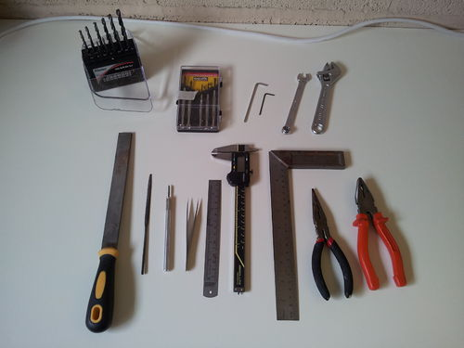

 Tools required for the mechanical build of the RepRapPro Mendel 3D printer:

1. Drill bits including 2mm, 3mm, 4mm, 5mm, 6mm, 8mm, 10mm

* Precision screwdriver set
* A set of metric allen keys including:
  + M3 size
  + one that fits inside a M3 set screw (allen key is smaller than M3 size)
* 13mm spanner (M8 nut)
* 10mm spanner (M6 nut)
* 5.5mm spanner (M3 nut)
* 5mm spanner (M2.5 nut)
* 15cm adjustable spanner
* File
* Half round needle file
* Craft knife
* Fine tweezers
* 300mm rule
* Vernier or digital callipers
* Square
* Fine nosed pliers
* Pliers
* Bench vice
* Side cutters
* For the Hot End Assembly you will also need some PTFE plumber's tape and a blowtorch

Electrical

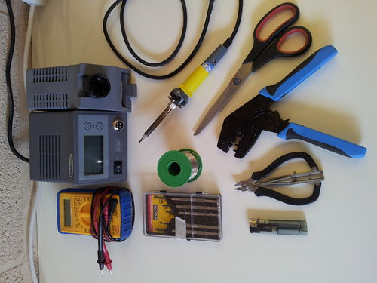

Tools required for the electrical build of the RepRapPro Mendel 3D printer:

* Digital Multimeter
* A fine-tipped soldering iron
* Precision screwdrivers
* Solder (flux is also useful)
* Hair dryer (or other heat source for heating heatshrink wire sleeving; the barrel of a soldering iron works OK)
* Wire strippers/cutters
* Ratchet crimp tool
* Molex crimp tool (such as the 63811-1000, you may also want the extraction tool 11-03-0044, Molexkits.com)
* Scissors

Next step

# [Frame assembly](http://reprap.org/wiki/RepRapPro_Mendel_frame_assembly)